2024
VCE
Specialist Mathematics
Year 12
Trial Examination 2

Detailed Answers


Kilbaha Education (Est. 1978) (ABN 47 065 111 373)  PO Box 3229  Cotham Vic 3101  Australia | PayID: 47065111373  Email: kilbaha@gmail.com  Tel: (03) 9018 5376  Web: https://kilbaha.com.au

All publications from Kilbaha Education are digital and are supplied to the purchasing school in both WORD and PDF formats with a school site licence to reproduce for students
in both print and electronic formats.
IMPORTANT COPYRIGHT NOTICE

- This material is copyright. Subject to statutory exception and to the provisions of the relevant collective licensing agreements, no reproduction of any part may take place without the written permission of Kilbaha Education.
- The contents of this work are copyrighted. Unauthorised copying of any part of this work is illegal and detrimental to the interests of the author.
- For authorised copying within Australia please check that your institution has a licence from http://copyright.com.au. This permits the copying of small parts of the material, in limited quantities, within the conditions set out in the licence.

Reproduction and communication for educational purposes The Australian Copyright Act 1968 (the Act) allows a maximum of one chapter or 10% of the pages of this work, to be reproduced and/or communicated by any educational institution for its educational purposes provided that educational institution (or the body that administers it) has given a remuneration notice to Copyright Agency Limited (CAL) under the Act.

For details of the CAL licence for educational institutions contact CAL,
Email: info@copyright.com.au

- All of these pages must be counted in Copyright Agency Limited (CAL) surveys

- This file must not be uploaded to the Internet.

These suggested answers have no official status.

While every care has been taken, no guarantee is given that these answers are free from error. Please contact us if you believe you have found an error.

CAUTION NEEDED!
All Web Links when created linked to appropriate Web Sites. Teachers and parents must always check links before using them with students to ensure that students are protected from unsuitable Web Content. Kilbaha Education is not responsible for links that have been changed in this document or links that have been redirected.

Kilbaha Education (Est. 1978) (ABN 47 065 111 373)  PO Box 3229  Cotham Vic 3101  Australia | PayID: 47065111373  Email: kilbaha@gmail.com  Tel: (03) 9018 5376  Web: https://kilbaha.com.au

SECTION A

ANSWERS

1 |  | A |  | B |  | C |  | D
2 |  | A |  | B |  | C |  | D
3 |  | A |  | B |  | C |  | D
4 |  | A |  | B |  | C |  | D
5 |  | A |  | B |  | C |  | D
6 |  | A |  | B |  | C |  | D
7 |  | A |  | B |  | C |  | D
8 |  | A |  | B |  | C |  | D
9 |  | A |  | B |  | C |  | D
10 |  | A |  | B |  | C |  | D
11 |  | A |  | B |  | C |  | D
12 |  | A |  | B |  | C |  | D
13 |  | A |  | B |  | C |  | D
14 |  | A |  | B |  | C |  | D
15 |  | A |  | B |  | C |  | D
16 |  | A |  | B |  | C |  | D
17 |  | A |  | B |  | C |  | D
18 |  | A |  | B |  | C |  | D
19 |  | A |  | B |  | C |  | D
20 |  | A |  | B |  | C |  | D

SECTION A

Question 1 Answer C

h: the heating is on
the room is not cold
If the heating is on then the room is not cold
the contrapositive is if the room is cold, then the heating is not on.

Question 2 Answer D

has as a horizontal asymptote and a vertical asymptotes,
so three straight line asymptotes provided , Alan is correct
If then consider when , as a horizontal asymptote and a vertical asymptote and is a point of discontinuity,
or consider when , as a horizontal asymptote and a vertical asymptote and is a point of discontinuity, Ben is correct.
and so is the y-intercept and is the x-intercept,
Colin is correct.

Question 3 Answer B

If , , is true in the first and fourth quadrant only, so only when

Question 4 Answer B

Line has direction and
parametric equations .
Line rewrite as has direction
so the lines are parallel, and has the parametric form
equate the x components so then and
, so the two lines are in fact the same line.
Question 5 Answer A

Assume replace k with and show that

Question 6 Answer D

integration by parts, let
A. B. and C. are all incorrect.

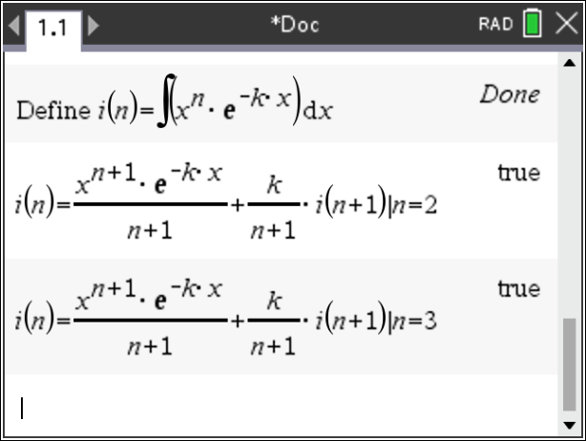
integration by parts, let

Question 7 Answer C
The distance of the plane from the origin is
Plane and gives or
the distance from the origin is
Plane the distance from the origin is
But the normals of the two planes are in the opposite direction, so the planes are on opposite sides of the origin, so the distance between the planes is
Question 8 Answer B
A particle is travelling on a circle, so that using implicit differentiation , so y decreases as x increases
the particle moves clockwise around the circle.

Question 9 Answer A

The scalar resolute of in the direction , is .
Let now
The scalar resolute of in the direction is
Question 10 Answer D
where is a unit vector perpendicular to both and , so
and A. is true
B. is true
If is parallel to , then and if is perpendicular to , then C. is true
D. is false.

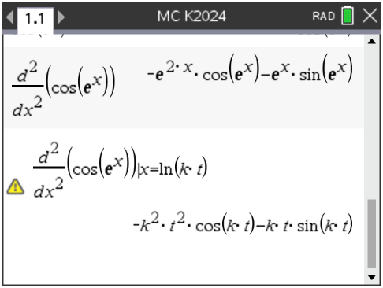
Question 11 Answer C

Question 12 Answer B

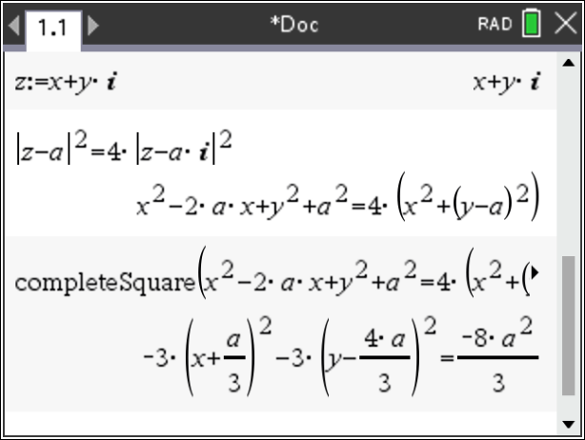
a circle

Question 13 Answer D
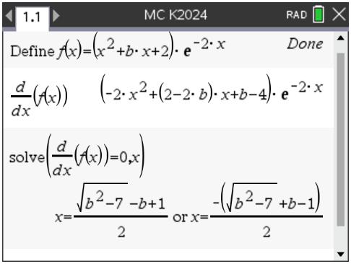
for turning points
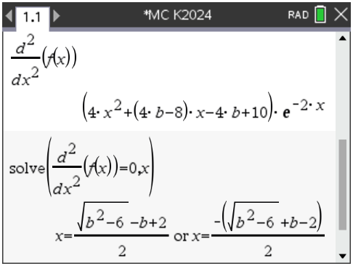
so there are two turning points if
one turning point if
and no turning points if
for inflexion points
so there are two inflexion points if , one inflexion point if and
no inflexion points if . A. B. and C. are all true, D. is false
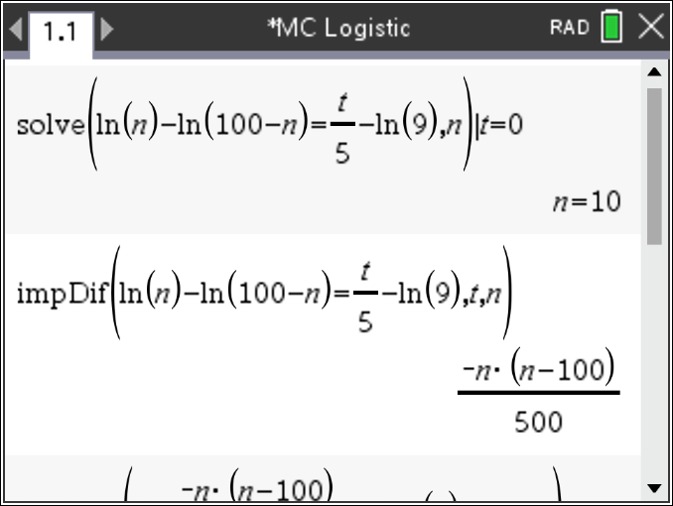
Question 14 Answer A

,
satisfies the differential equation
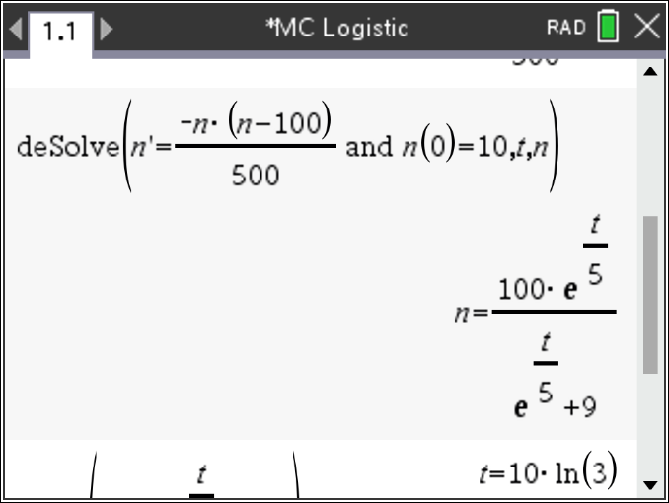
A. is false, B. C. and D. are all true
The initial number of penguins was 10 and
the number of penguins cannot exceed 100.
The solution of the differential equation is
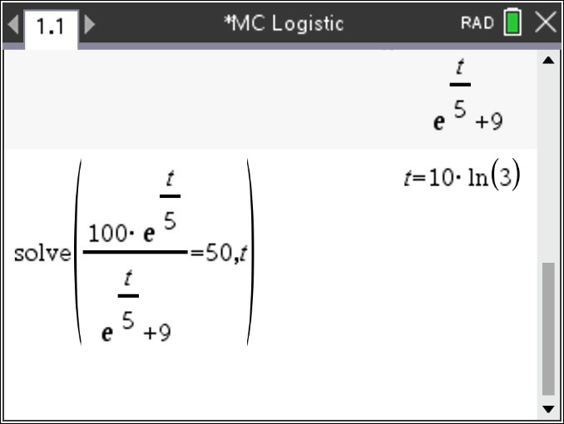
The penguin growth rate is increasing most rapidly
when

Question 15 Answer A
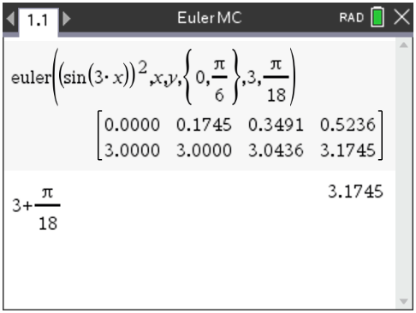
using Euler’s Method

Question 16 Answer C

when the slope and when , the slope
the slopes are never infinite, only satisfied by

Question 17 Answer C

The stone takes on the initial upwards speed of the balloon, but its acceleration is just due to gravity. Taking upwards as positive and downwards as negative,
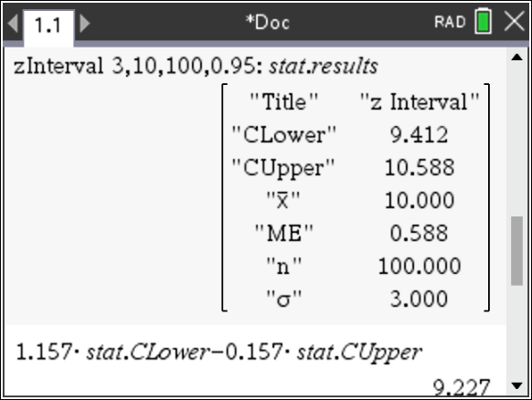

Question 18 Answer A
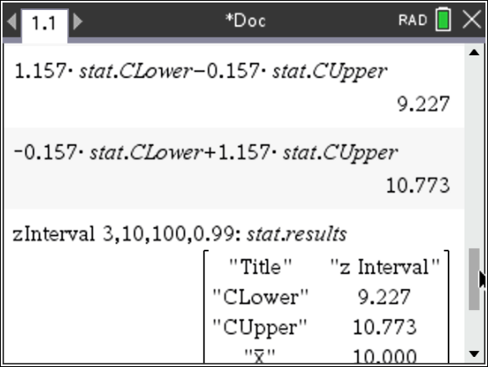

Question 19 Answer B

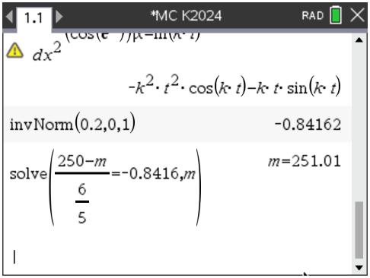

Question 20 Answer D

A. is true
The area of the triangle when is
and when is
The toy car moves a total distance of
metres. B. is true
The toy car has a displacement of
metres. C. is true
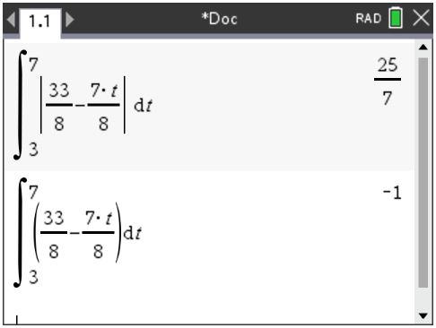

D. is false the average speed is the total distance travelled over total time.

END OF SECTION A SUGGESTED ANSWERS
SECTION B

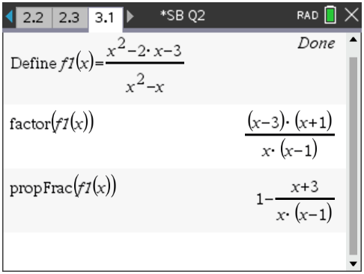
Question 1

a.
and are vertical asymptotes,
and is a horizontal asymptote.
Note the graph will cross the horizontal asymptote at A1
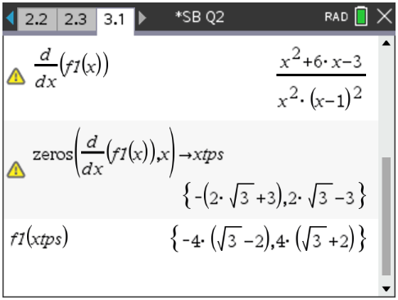
b.

for turning points
solving
gives

A1

c. The graph crosses the x-axis at and , G3

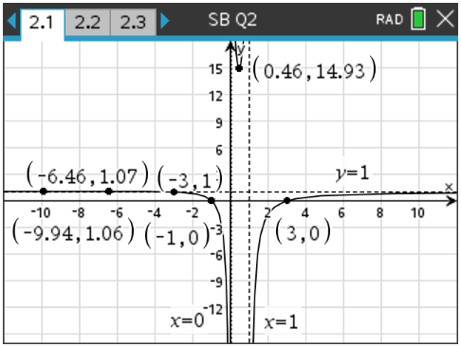
d.i. when
when the graph has a point of discontinuity and will have no turning points A1

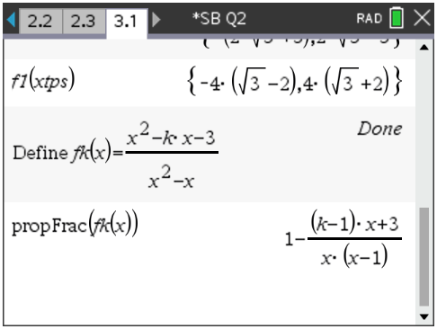
ii.

The graph will cross the horizontal asymptote when A1

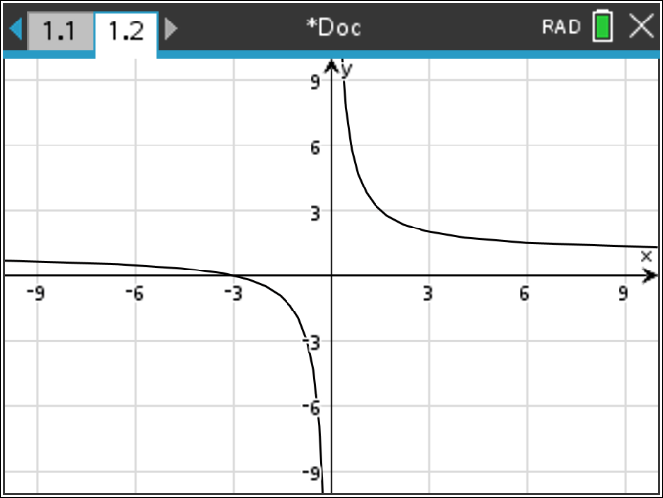
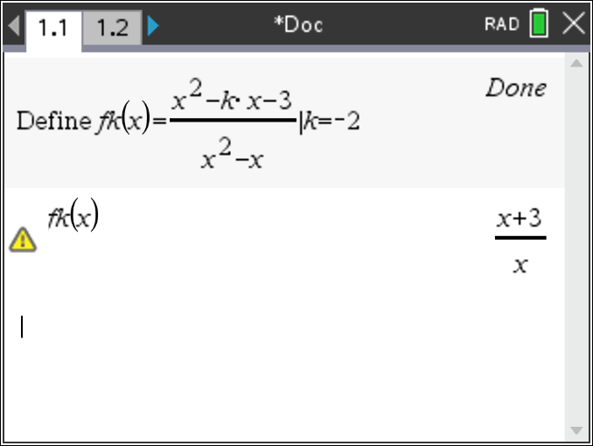

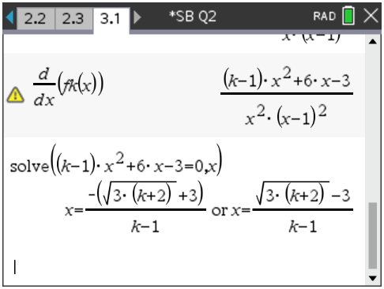
iii.
for turning points
solving
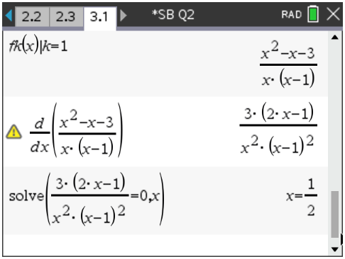
gives
investigate the case when

values of k | the graph of has
 | two turning points
 | one turning point
 | no turning points | A3
or | no points of inflection
 | one point of inflection

Use a slider on the graphs page for k forand watch the inflection point appear and disappear
or use trial and error for the inflection points.
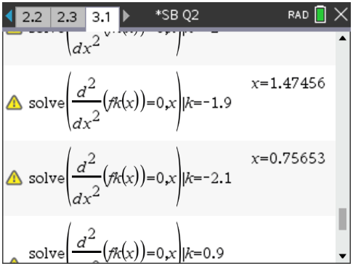
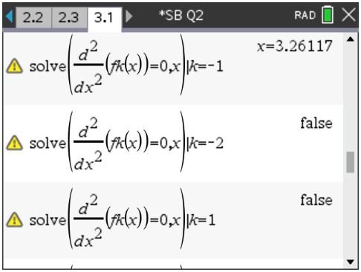
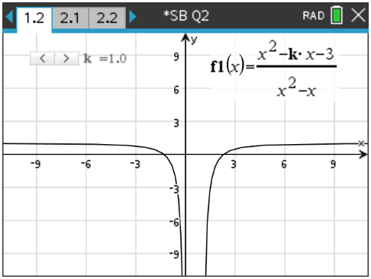
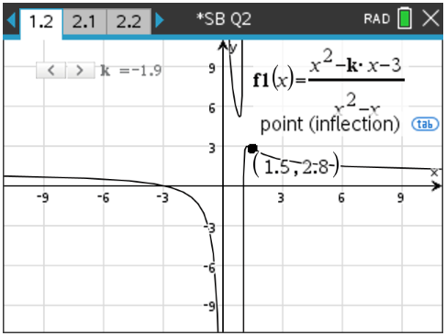

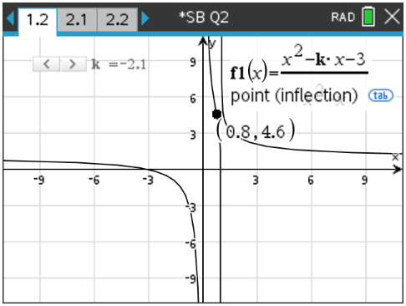
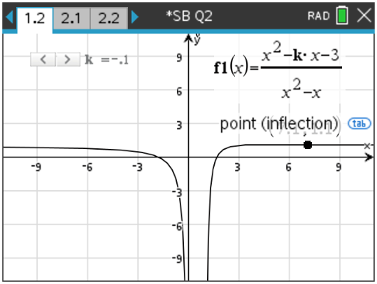
Question 2

a.i.
is a circle centre at is a circle centre at
radius 2. radius 4. A2

ii. solving with gives A1
iii. the line through has a gradient
the ray is for draw with open circle at A1
now the angle the ray makes with the positive x-axis is
A1
b. G2
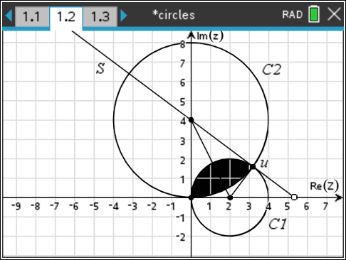
c. Consider three areas
Area 1: the area of the sector of radius 2, with an angle of where
A1
Area 2: the area of the sector of radius 4, with an angle of but so that
A1

Area 3: the area of two right angle triangles with side lengths 2 and 4, the total area of both
triangles is
The required area is
A1

Alternatively using calculus
the top half of the circle is
the bottom half of the circle is A1
The required area is
A1
A1
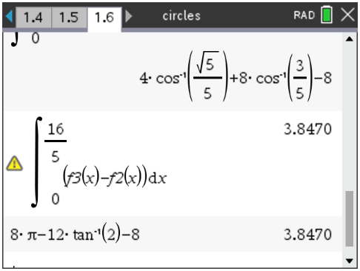

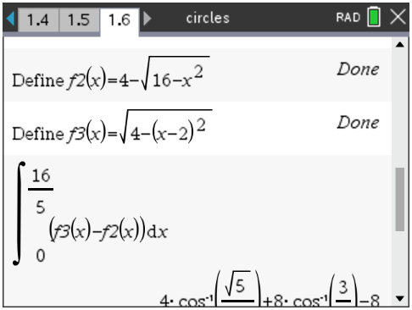
Which is equivalent to

Question 3

a.i. solving when A1
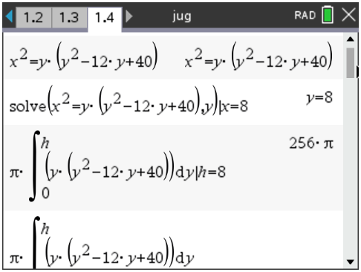
A1

ii.
A1

b.i.
A1
M1
A1

ii. A1

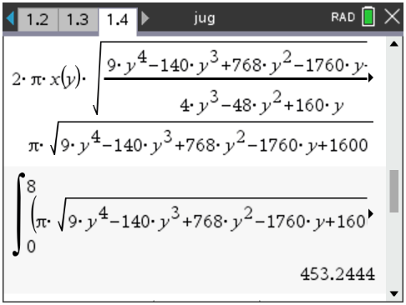
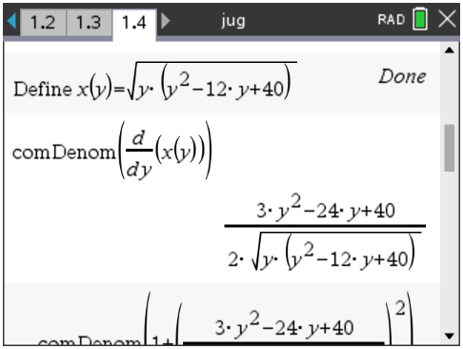
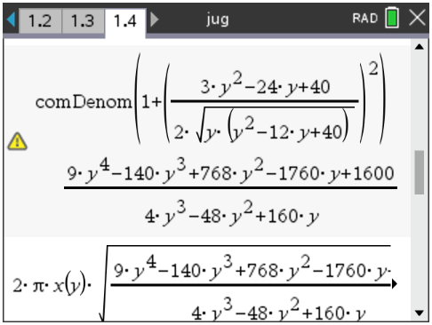

c. A1
M1
solving gives A1
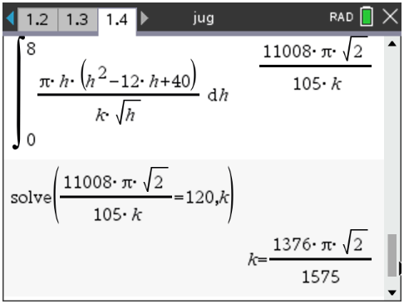
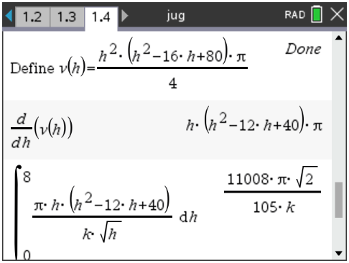

Question 4

a.
,
A1
M1
M1
need to check in yes A1
so the time between release is seconds and the point of collision is
A1

b.

the vector has a length of c so
and makes an angle of with the positive x-axis.
the vector has a length of d so
and makes an angle of with the positive x-axis
Alternatively by the cosine rule, since is the angle between the vectors and
so that A1
To prove that is equivalent to proving
A1
To prove this use a proof by contradiction, assume that
now square both sides A1
but since and , so
hence we have a contradiction, so the original statement A1
must be false,
hence
Question 5

a.

The plane has a normal let the point
be the point on the plane closest to the point .
The vector is parallel to the normal to the plane,
so that , then M1
rearranging
but since lies on the plane M1
solving
substituting gives and
A1

Alternative methods are possible.

b.

The line has direction
and in parametric form is
let the point be the point on the line which is closest to the point
The vector is perpendicular to the direction of the line,
so that , so that M1
The point also lies on the line and the vector is parallel to the direction of the line so that and A1
rearranging substitute into
M1
solving
substituting gives and
A1

Alternative methods are possible.

c. , and the plane .
Now the direction of the line and the normal to the plane
are perpendicular since ,
therefore the line and the plane do not intersect. A1

Alternatively substitute into the plane
which is a contradiction,
so the line and the plane do not intersect.

The point is the same point as and lies on the line and
The point is the same point as and lies on the plane.
Since from a. the closest distance from the plane to the point A was and
from b. the closest distance from the line to the point B was also,
it follows that the distance between the line and the plane is also A1

d. the line
substitute into the plane
M1

i. for a unique point of intersection
ii. an infinite number of points of intersection
A1
alternatively the point on the line lies in the plane
and the normal to the plane
is perpendicular to the direction of the line
so that , so the line lies on the plane having
an infinite number of points of intersection.

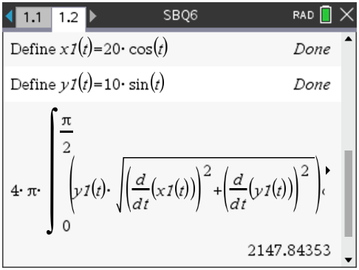
Question 6
a.i.
rotate around the x-axis

by symmetry
A1

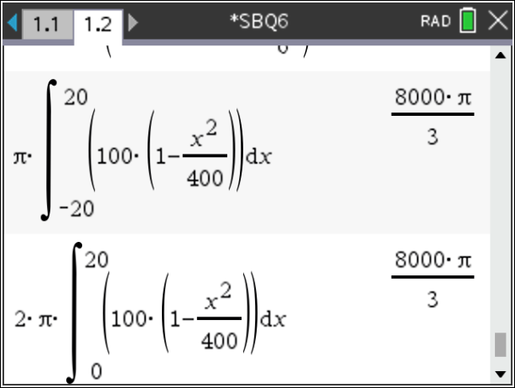
ii.
by symmetry

A1
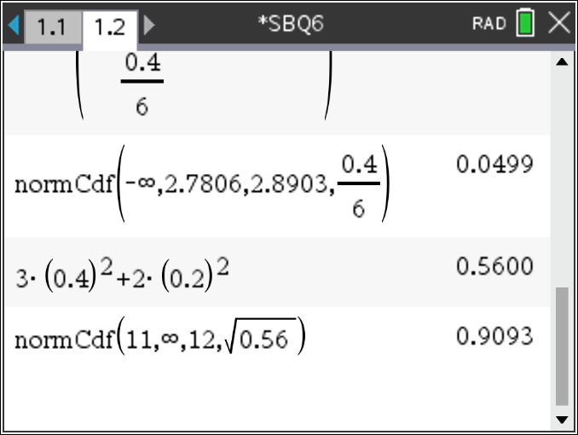
b. watermelons
cantaloupes
total of three independent watermelons and two independent cantaloupes
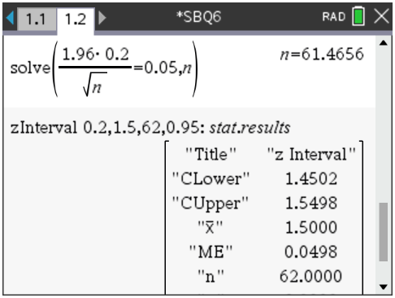
A1
c.

solving

gives so A1
d.
one-sided test A1

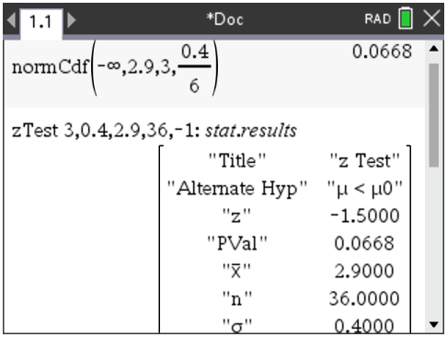
e.
A1
Since the p value
there is no evidence to support the
alternative hypothesis A1
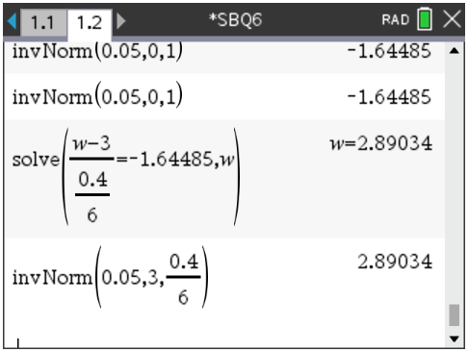
f.
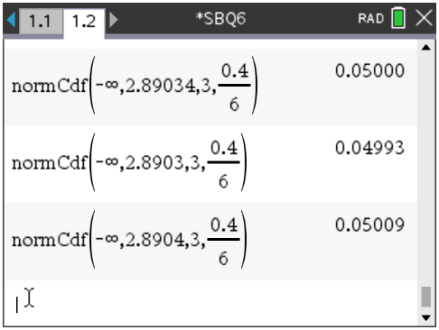
so round up A1

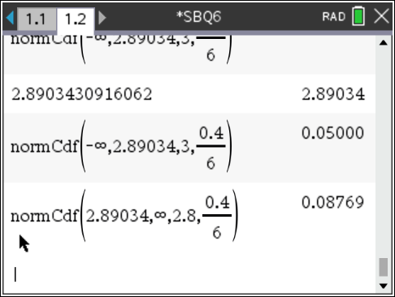
g.

A1

End of detailed answers for the

2024 Kilbaha VCE Specialist Mathematics Trial Examination 2

Kilbaha Education (Est. 1978) (ABN 47 065 111 373)  PO Box 3229  Cotham Vic 3101  Australia | PayID: 47065111373  Email: kilbaha@gmail.com  Tel: (03) 9018 5376  Web: https://kilbaha.com.au

